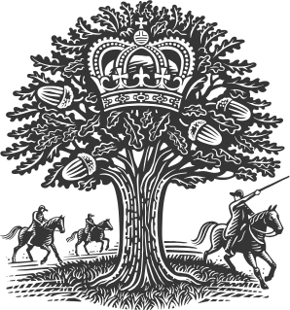

It is on a cold evening, with a warm heart that we welcome you back!

Do keep in touch, follow us on Instagram (@royaloakramsden) and
sign up to our newsletter via royaloakramsden.com.

THE ROYAL OAK

Welcome to Supper Club

‘A WINTER’S NIGHT’

Wednesday 2nd December

Food course £45 Drinks course £29
Individually priced drinks inside

Arrival drink, freshly baked bread & butters
~

Roasted Jerusalem artichoke, goat’s cheese mousse, hazelnut
~

Halibut, onion & bacon tart, baby turnips, vin Jaune

125ml Estones Pedro Ximenez, Spain £8
~

Beef Wellington, beef fat mash, cavalo nero, port wine sauce
250ml Morgon Les Grands Cras 2018 £10
~

Frozen blackberry parfait, blackberry & anise sauce
~

Baron Bigod cheesecake, shortbread

Gonzalez Byass Apostoles Palo Cortado Sherry £9
~

Tobacco ganache

Mint Chocolate Vodka Liqueur £4

